**Multimode Fiber Amplifier With Configurable Pump - Simulation Utility**

User Manual

Run the utility by running the ‘GainInMMF_sim2.m’ file. The Matlab GUI will appear.

**Step #1 – Defining the fiber and the optical wavelengths**

At the upper left side of the utility, the relevant parameters of the fiber guidance (core radius, NA, core index) may be chosen, as well as the gain element (Erbium or Ytterbium) and the wavelengths of the two interacting lightbeams. The calculation of the number of guided spatial modes, and their precise spatial distributions, takes into consideration the values set for all these parameters.

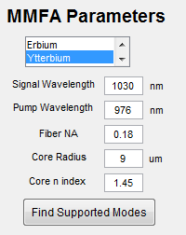

Once the desired values have been set, press the ‘Find Supported Modes’ button.

**Step #2 – Configuring the pump beam**

At the upper right side of the utility, the pumping configuration, i.e. the pump beam’s modal content, may be viewed and controlled. The supported pump modes are displayed in tables, whose columns and rows represent the radial ‘m’ index and the angular ‘l’ index respectively. The full configuration contains 4 different tables: 2 tables for the amplitudes and the phases of the ‘even’ modes (those defined by a cosine angular term), and 2 tables for the amplitudes and the phases of the ‘odd’ modes (those defined by a sine angular term). Access to these 4 tables may be done using the pair of toggle buttons below the table area. The values may either be changed manually by writing values one by one into the table cells, or using the buttons to the right of the table, which facilitate the setting of values (zeros, ones, or randomly distributed) to all the cells at once.

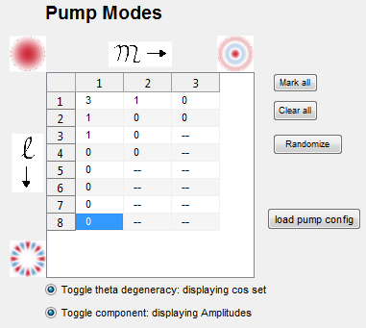

Once the desired values for the pump modal configuration have been set, press the ‘Generate Injected Pump’ button. The requested configuration will then be numerically realized, using a spatial XY grid whose size is defined by the ‘# of points’ parameters.

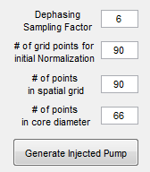

The pump intensity pattern at the injection plane is automatically displayed; a visualization of the intensity will evolve along the fiber length as the pump beam propagates within it is readily available by pressing the ‘Play’ button.

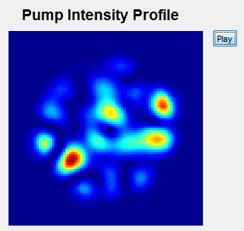

**Step #3 – Defining the amplifier parameters**

The full calculation of the transmission matrix of the MMFA may now be carried out. At the lower left side of the utility, the parameters dictating the amplification along the z axis (the fiber length, the doping concentration, and the injected pump power) may be chosen.

Once the desired values have been set, press the ‘Calculate Full TM’ button. The numerical evaluation will be launched; upon its termination, the results, i.e. the transmission matrix, will be displayed in a separate folder, and will also be automatically saved as a Matlab variable in the current folder (with a file name containing the time stamp at the moment of saving).

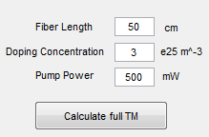

**Example of Results**

